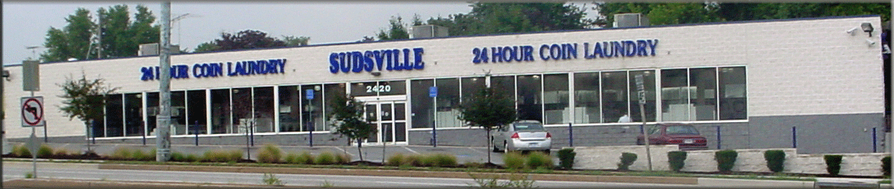
A Sudsville Laundry Center is proposed for Overlea Fullerton on the vacant McDonald’s lot in the 7500 block of Belair Road. Since this has been brought to my attention, OFBPA has been on a fact finding mission to find out “what Sudsville is all about”. I’ve met with Dan Trupia, the president of Linover Improvement Association and we both met with Chuck Moberly, Sudsville Operations Manager just prior to Linover and OFBPA’s meetings last week. We were both in agreement that we wanted to present as many facts as possible to our memberships. Chuck met us on site at their Loch Raven site and even gave Dan and me a pack of photos to share with our members.
I would like to share the FYI that Dan and I have gathered as we spoke to Sudsville and others on their proposal.
- Sudsville Laundry, Inc. is locally owned and operated. The owner took over the family business after running it with his father for 25 years. Sudsville has been a leader in the coin laundry industry since 1958. There are currently16 self-service coin laundry locations in Baltimore County, Baltimore City, and Prince Georges County. All locations are open 24 hours, 365 days a year. They offer 80,60,40,30, and 20 lbs. washers. They have 2 sizes of dryers 50 lb. and 30 lb.
  - Sudsville is a well-lit, well maintained property both inside and out.
  - Sudsville is strictly vending machine sales only for laundry items as well as drinks and snacks.
  - Sudsville will be a 10,472 square foot, approx. a 3 million dollar project bringing in new construction to our area. They use their own contractors and hire locally.
  - Sudsville will have 20-30 security cameras on site.
  - Sudsville at no times allows solicitation or loitering on any of its properties. If anyone leaves brochures or flyers in their businesses, they are automatically trashed.
  - Sudsville assured us that the safety of their staff and clients are always a priority. Dan and I raised a concern about their back access door being opened late at night. The rear and side doors will be locked every night between 10 pm and 12 pm until daybreak and only opened by the employee as needed.
  - Sudsville operates under high standards and has a great reputation in the business community as well as being known as one the best laundry operators in the country.
  - A Sudsville client ranges from the local home owner who wants to do 8 loads of laundry in 90 minutes, to the person whose washer and dryer just went up, to the occasional user who needs to wash blankets and comforters each season. There is something for everyone.
- Currently Sudsville is doing a “Feasibility Study” for the Belair Road property.
  - Having multiple sites already in Baltimore County, they are not “newbies” at this process and are known on a first name basis in the County Offices.
- Currently Sudsville is in negotiations with McDonald’s to purchase the property.
  - I spoke with Colliers International- the Commercial Real Estate Broker for the property and they confirmed that McDonald’s has a 20 year moratorium on the property of ever being sold to a “food” entity or food service business of any kind. It will actually be in the deed of the property. McDonald’s says this “protects” its franchises that are nearby.
    - So as much as some hoped it would be –not an option and never has been.
    - Overlea Community Association stated that McDonald’s owns Chipotle and could that be an option—the answer is McDonald’s had a partial interest in Chipotle and no longer (or has very little of an interest) in Chipotle since it went public. Again, was never an option.
- Collier’s also told me that even if the moratorium was not in place, due to the size of the property, location in the middle of the block without ease of access and the current zoning restrictions, it would be very difficult for any type of “fast food” business to purchase this lot as it truly cannot accommodate the current size and requirements needed for modern sites.
- Collier’s also told me that they also did their research on Sudsville and contacted a friend in real estate and said they were a family run business with an excellent reputation.
- I contacted Councilwoman Cathy Bevin’s office to inquire on any updates. They are aware of the feasibility study and no concerns have come to their office to date. They will be kept abreast of any concerns from any of the county agencies involved.
  - Cathy’s Office wrote this to me in an email today “Councilwoman Bevins welcomes the new business to the area, especially if it is well managed, but we are waiting to hear back from planning as to any county concerns”.
  - I will keep in touch with Cathy’s office as the project progresses
- Dan, from Linover also contacted a police officer friend and asked him how many Laundromats he had in his area. The office told him four. Dan asked how many crimes they been called to on those sites. Officer told him none. His friend is an officer in the Essex Precinct.
So these are the facts as Dan and I know them to date. Dan and I received very few questions at our respective meetings and in fact the ones raised by the members who attend the February meeting were questions Dan and I asked at our meeting with Chuck and received answers for. Consensus was positive at our meeting and everyone was looking forward to a new business that plans to be in the area long term. As they stated, “Anyone who is going to spend that kind of money is going to take care of their property, maintain it and will be a great business neighbor”. I don’t think we could ask for anything more. We have seen the results of this at the Beltway Plaza as David S. Brown who operates under the same premise- locally owned, operated and maintained and we have the best plaza on the corridor, due to their business model.
Overlea Community Association came out in opposition as soon as they heard what was being proposed. To summarize their concerns they perceive Laundromats as being in “less desirable areas” and the assumption that those coming to the area will increase crime. They look at it a place for drug dealers, prostitutes and the homeless to “hang out”. They are also concerned that clients of Sudsville people will visiting the liquor store next door and use the parking lots of either business in which to drink and loiter.
To those concerns, I’m not sure Timonium/Cockeysville where a Sudsville is currently would care to be known as a “less desirable area”. I am also not sure that a 24/7 well-lit building is the place that drug dealers and prostitutes do business?? Can you ever say that someone doing laundry doesn’t walk over to the liquor store? Absolutely not. However do you seem a mom and two kids doing this on a regular basis? Probably not?
In closing, I would like to say that OFBPA and Linover are looking at this new business as a positive and hoping this will attract other new businesses to our area. I see a mom and a couple of kids having a doughnut across the street at the Dunkin’ Donuts or maybe stopping at Subway, 7-11 or Rita’s to enjoy lunch or a snack while waiting for laundry to finish. Maybe mom drops of the older kids to watch a movie while she does laundry. Can any new business bring the potential for crime? Absolutely, but I truly feel that one of the advantages to our corridor is the fact that our community associations are very pro-active and “notice” things and address them quickly.
I feel that Dan and I have established an open relationship with Sudsville and are confident that any concerns prior to them opening and after they are open will be addressed quickly and to everyone’s satisfaction. OFBPA intends to be proactive and will help Sudsville promote their new business as we do with all businesses on our corridor.
I encourage anyone who has any questions or additional concerns to contact Operations Manager, Chuck Moberly at 410-252-4877 or chuck@sudsvillelaundry.com. He is open to all comments and questions. He also invites anyone to visit any of their locations.

