 

Join the Overlea Fullerton Rosedale Business Association

Networking Happy Hour & Appetizers at Skipjack’s- 5 pm

Wednesday, November 14, 2018

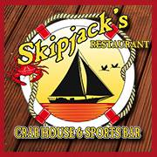 **OFRBA Networking Happy Hour**

**Date:** **Wednesday, November 14, 2018**

**Where**: 7703 Belair Road (21236) Across from Beltway Shopping Center

[**Phone**](https://www.google.com/search?rlz=1C2AVNG_enUS670US670&biw=1641&bih=900&q=pizza+hut+baltimore+county+phone&stick=H4sIAAAAAAAAAOPgE-LWT9c3LEnPSDM2MtPSz0620k_Oz8lJTS7JzM_Tz87LL89JTUlPjS9IzEvNKdbPSCyOL8jIz0u1ApMAf9aqA0AAAAA&sa=X&ved=0ahUKEwimmvWCwdHTAhWJ6oMKHYZJDcIQ6BMImgEwEQ)**:** 410-665-7500

**Time:** 5:00 pm

**Cost:** $20.00 (includes one drink ticket and appetizers)

**RSVP:** [**https://tinyurl.com/ofrba-1114**](https://tinyurl.com/ofrba-1114)

* **Bring plenty of business cards and flyers to share and updates on your business!**
* **Door Prize drawings**
* **Bring a business neighbor and get an extra entry into our door prize drawing!**
* **Meet Herbie the Hedgehog- our plush toy for the shelter—drive starts now-need 100 for Dec. party**
* **Membership accepted for 2019. Shelter party updates.**

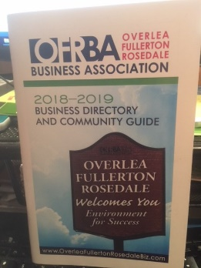 **2018-2019 Business & Community Guides available for pick up!**

**Until our board gains more volunteers we are unable to deliver these to our members like we have done in the past. So we will have them at our next 3 meetings and would appreciate someone coming to pick them up during meeting times or call to pick up from BB&T between M-F between 9 am – 4pm. Please contact Teresa Lough or her staff to make arrangements at** [**TLough@BBandT.com**](mailto:TLough@BBandT.com) **or 410-657-9021.**